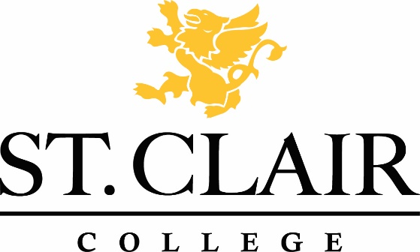

RESEARCH ETHICS BOARD

REB Application Submission Checklist

Please submit a single complete package for initial review by the Research Ethics Board.

Completed and typed multi-site application form including all necessary signatures. All questions on the form must be answered. If the question is not relevant, please indicate with an N/A.

An electronic version of the application emailed to ethics@stclaircollege.ca for the REB Chair.

Completed Administrative Approval of Research Activity Form (to be forwarded to the Senior Operating Group). Note-this is a required separate clearance process.

Evidence of REB approval in other jurisdictions where the research is to be conducted (where applicable).

Letter of support from academic committee/supervisor (for student projects) if applicable.

Letter(s) of support from collaborating agencies/institutions (where applicable).

Proof of award of funds (for grant funded research) and contract included (where applicable).

All recruitment tools (e.g., information letters, advertisements, posters, notices, etc.). If a website is being used to recruit subjects, please include the website address.

All relevant Consent Form(s)/Assent Form(s).

TCPS 2: CORE 2022 or training materials provided in PDF form for all members of the research team.

Questionnaire/study instrument(s)/interview questions/forms to be used in carrying out the research (where applicable).

Other REB clearance letters in PDF form.

